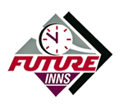**Breakfast To Go Order Form**

**Room No:**

**Name:**

**Collection Date: Time:**

**The Breakfast Bag To Go comes with a drink, sandwich, drink, cereal bar and a banana muffin.**

*Choose one from each selection*

# **Drinks**

Orange Juice q

Apple Juice q

Can of Soda q

Bottled Water q

# **Sandwiches**

Bread: Brown q White q Gluten-free q

Bacon and Tomato q

Ham and Cheese q

Cheese and Pickle q

Hummus and Peppers q

# **Fruit**

Apple q

Orange q

Banana q

**Special Dietary Requirements**

We are delighted to cater to special dietary requirements, offering options such as vegetarian, vegan, gluten-free, or dairy-free meals. If you have any allergies, please inform us during the booking process.

We kindly request that you pre-order special dietary requests with a minimum of 48 hours' notice. Your understanding is greatly appreciated.

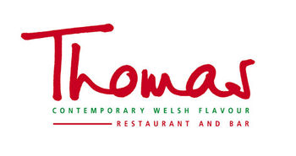*Thank you for choosing Thomas Restaurant*